Live Light Live Right joins Bike New York for a FREE Cycling program for Kids
When?
Saturday July 25th – Aug 29th, 2015
9.30am – 11.30am
Where?
Camba Beacon
Corner of Linden Blvd & Van Siclen Bus: B83
Subway: 3 to Van Siclen (4 Blocks to site)
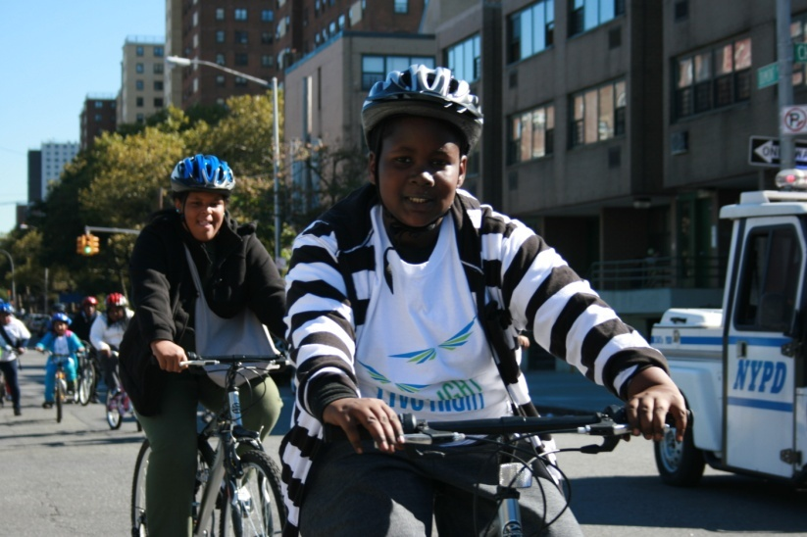
What?
- First Time? Don’t worry, learn to ride...
- Master Bike Safety Skills
- Take group bike rides to discover your neighborhood
- Learn teamwork with other cyclists
- Bikes, helmets, trained leaders, and FUN provided...
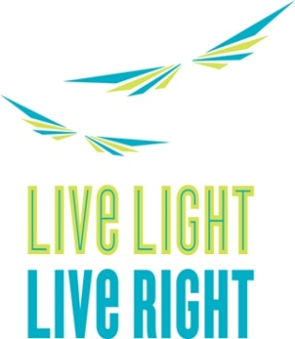
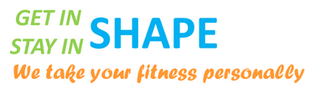
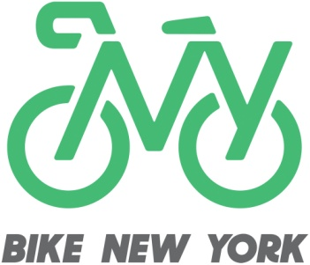

Contact Information (718-240-8125)
Visit us on our Website http://livelight.org/

